**COS30043: Interface Design and Development**

**Pass Task 3.2: Lookup Web App**

**Name: Tran Quoc Dung**

**Student ID: 103803891**

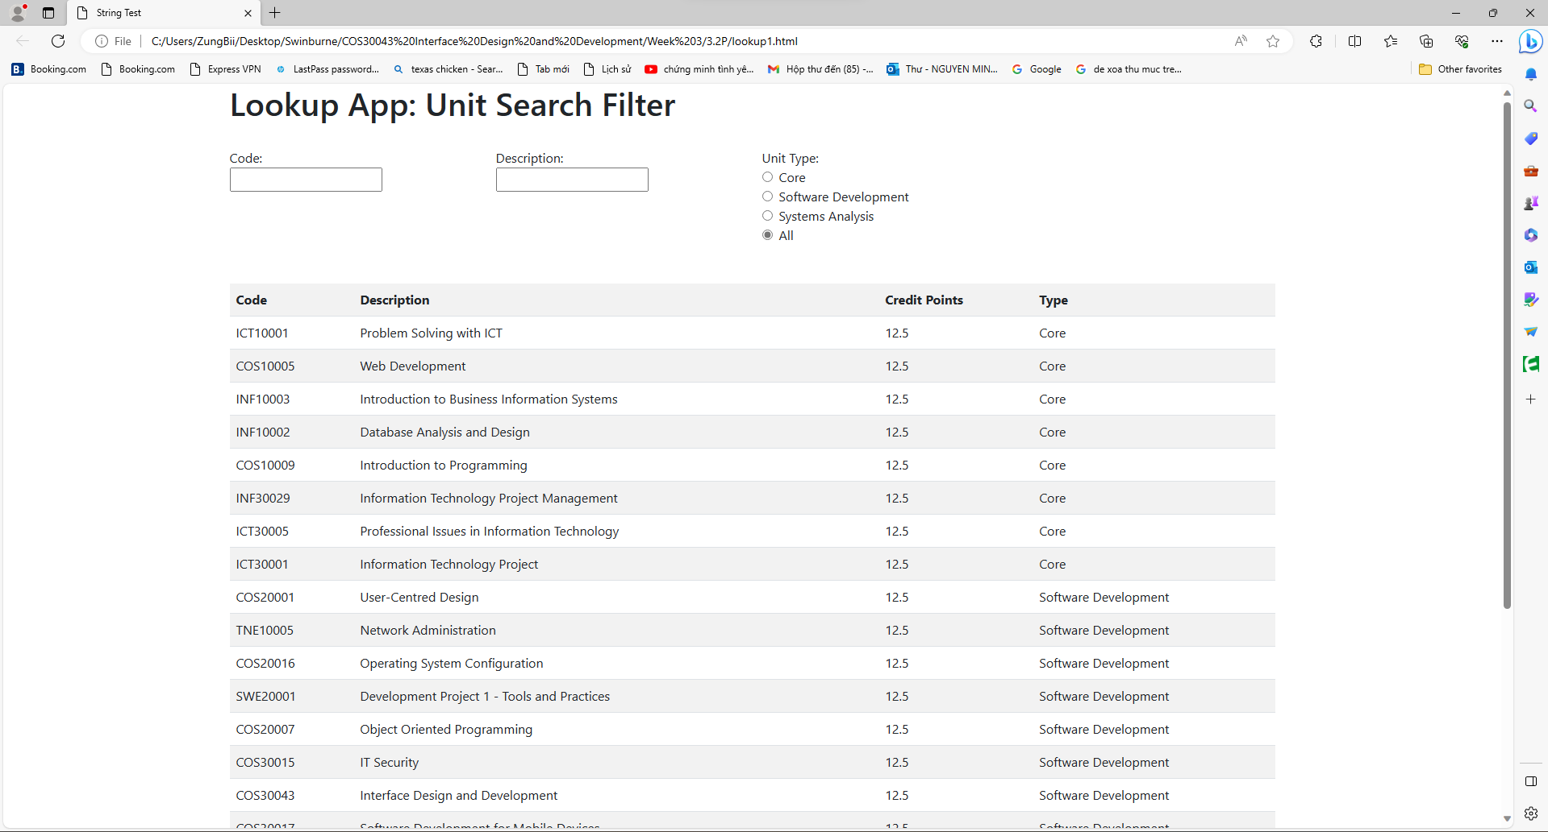

Lookup App Webpage.

Results of lookup function (findSubject).